Application Report

ALE1

Raditya Surya - 2221796

2016

# Assignment 1 – Proposition Logic Formula & Graphical Representation

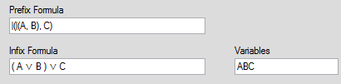

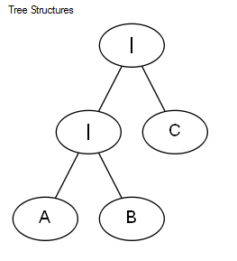

# Assignment 2 – Truth Table & Hash

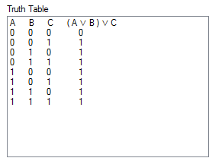

C:\Users\Raditya\AppData\Local\Microsoft\Windows\INetCacheContent.Word\ale_08.png

# Assignment 3 – Simplified Formula

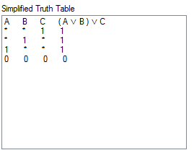

# Assignment 4 – Disjunctive

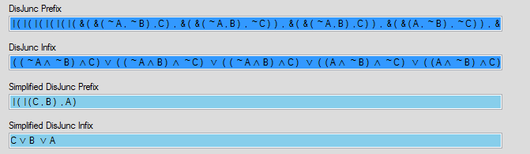

# Assignment 5 - NAND

